Ideation Phase

Define the Problem Statements

Team ID

Project Name

PNT2022TMID09835

Emerging Methods For Early Detection Of

Forest Fires
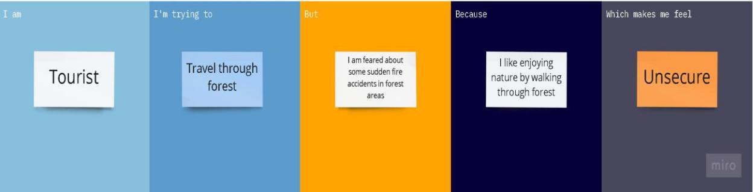

Problem | I am | I’m trying | But | Because | Which makes
Statement | (Customer) | to |  |  | me feel
(PS)
PS-1 | Forest | Collect Wood | Forest fires | During summer or | Many tall trees are
 | worker |  | occurs | even due to human | damaged and
 |  |  |  | activities | animals are killed
 |  |  |  |  | when they are
 |  |  |  |  | struck in between
PS-2 | Forest | Save animals | Mostly | Because of high | Not satisfied with
 | officer | and trees | unable to do | temperature and | my job
 |  |  | so | dry Wood and
 |  |  |  | even Thunder
 |  |  |  | attacks during
 |  |  |  | rainy season
PS-3 | Tourist | Travel | I am feared | I am very much | Unsecure most of
 |  | through | of forest | interested in | the times
 |  | forest | fires | viewing middle
 |  |  |  | forest wonderful
 |  |  |  | locations
PS-4 | Goods | Pass through | Some areas | We need to travel | Think about
 | carrying | forest | where I | long distance | crossing that
 | Driver |  | usually |  | forest in a safe
 |  |  | travel is well |  | manner
 |  |  | known for
 |  |  | some fire
 |  |  | accidents

